

**AMERICAN INTERNATIONAL UNIVERSITY–BANGLADESH (AIUB)**

**Department of Computer Science  
Faculty of Science &Technology (FST)  
Fall 21_22  
ADVANCE DATABASE MANAGEMENT SYSTEM**

**Section: C**

**Supervised By**

**REZWAN AHMED**

**Submitted By**

|  |  |
| --- | --- |
| **Name** | **ID** |
| **MD. ALI AHNAF** | **20-42378-1** |
| **PROTIK ACHARJAY** | **20-42715-1** |
| **SHAIKH KINGSHUK AL-AZIZ** | **20-42374-1** |
| **MD. SADIK HOSSAIN CHOWDHURY** | **20-43427-1** |

**Table of Contents:**

System Summary………………………………………………………………………3

ERD Diagram………………………………………………………………………….4

Class Diagram………………………………………………………………………….4

Use Case Diagram……………………………………………………………………..5

Activity Diagram………………………………………………………………………6

Schema Diagram………………………………………………………………………7

Screenshots of Sample Data……………………………………………………………7-10

Query Writing…………………………………………………………………………. 10-11

User Interface for Login and Registration ……………………………………………..11-12

**System Summary:** The purpose of the project is to deliver authentic Razer products (which is shipped from the US) through a user-friendly, strong security, reliable purchase system which will be provided through the webpage Razer Store Bangladesh. Therefore, not only gamers, office-workplace users but also the people who seek for authentic razer products at a reasonable price can purchase without any hesitation or discomfort. The webpage is secured through proper PHP-validation, JavaScript and the resources are protected via appropriate Session-Cookie implementation. Lastly to prevent SQL injection prepared statement was implemented.

**Main Functionalities:**

* User can comment and can view comment other user’s comment in the same page without reloading the page. Here Ajax is used and from SQL database comment was limited by two in descending order.
* Because of the JavaScript client server implementation user cannot send blank in the forms
* Can view the products in the store and can add products to the cart which gets updated and can select the desired quantity of the products which user wants to purchase by using SESSION the Cart Items and Quantity stays updated and remains in the cart index in till checkout has been made.

User can check out his payment where he can pay total amount of the product via cash on delivery.

**ERD Diagram:**

**Class Diagram:**

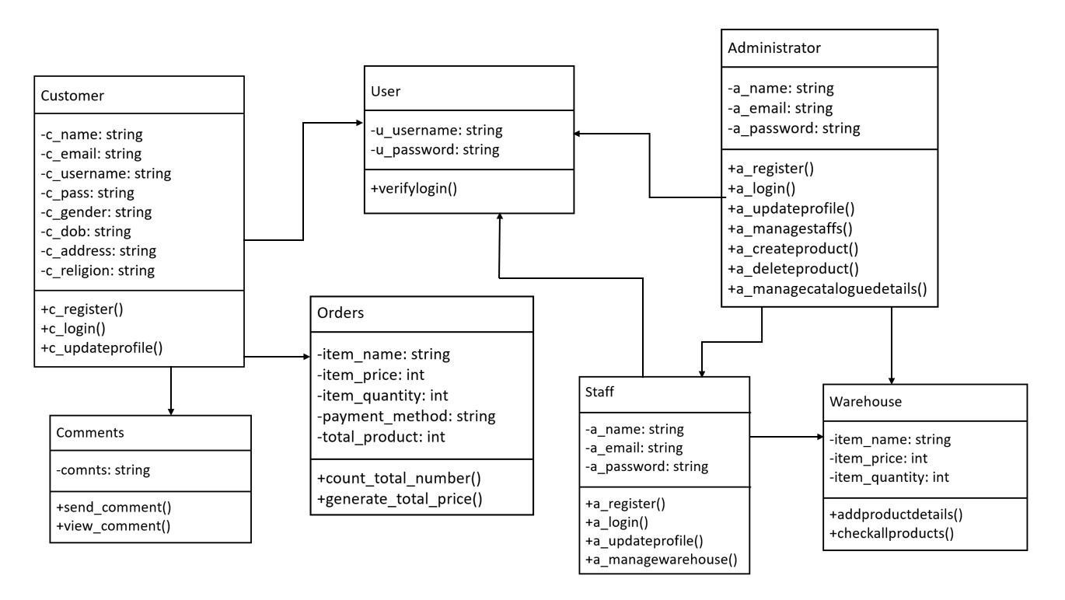

**Use Case Diagram:**

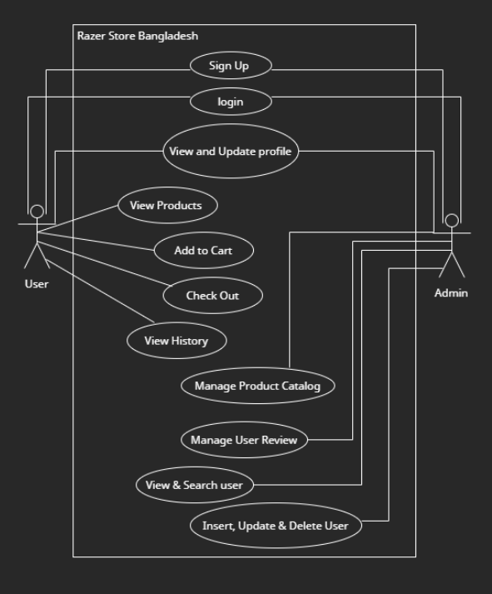

**Activity Diagram:**

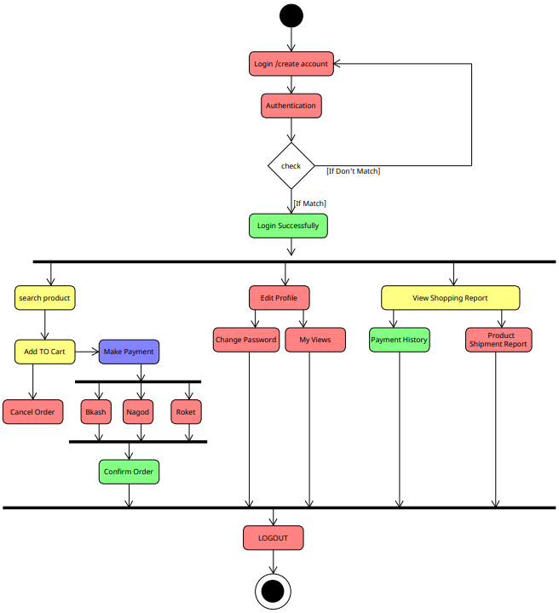

**Schema Diagram:**

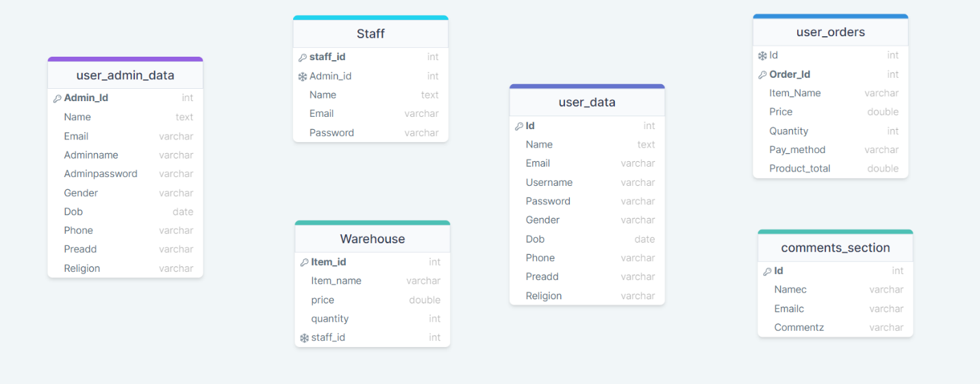

**Screenshots of Sample Data:**

**User_Data Table:**

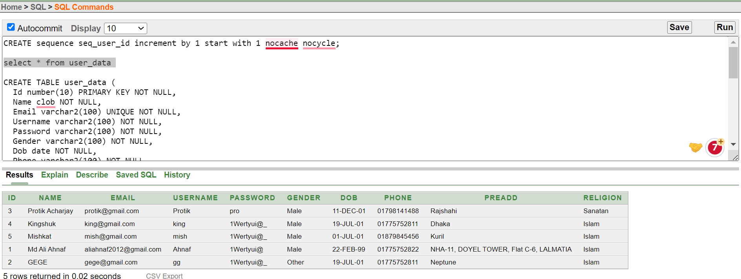

**User_Admin_Data Table:**

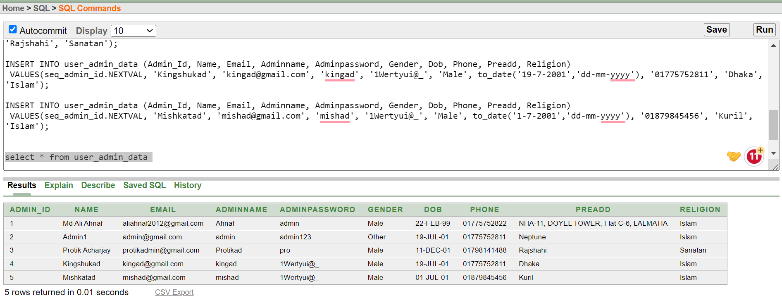

**User_Orders Table:**

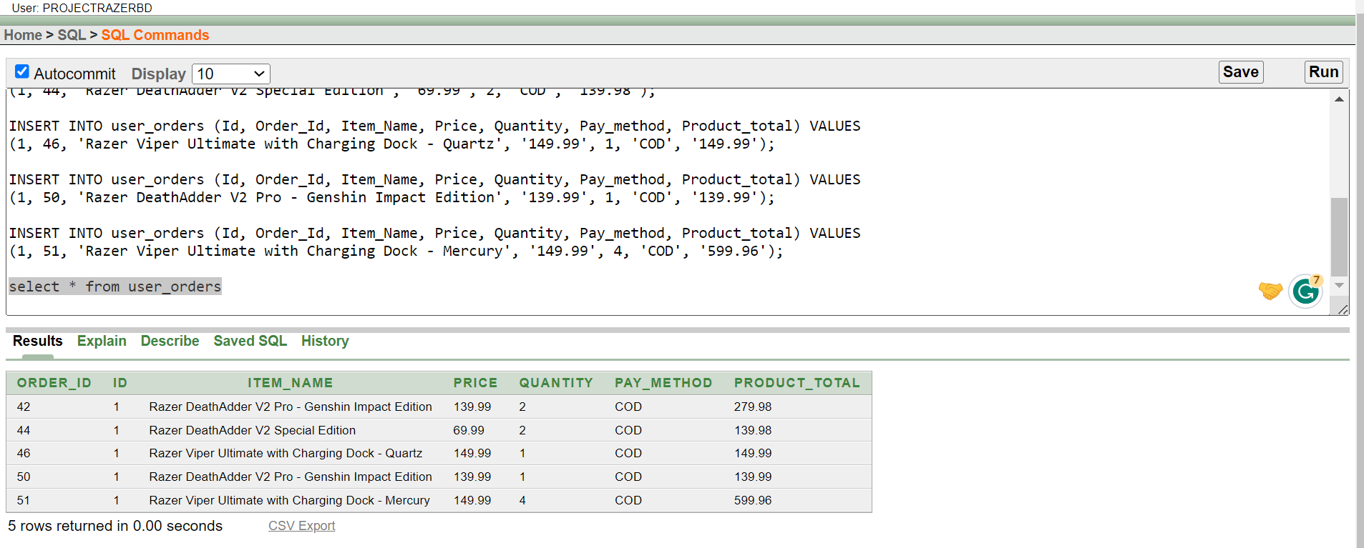

**Comments_Section Table:**

**Staff Table:**

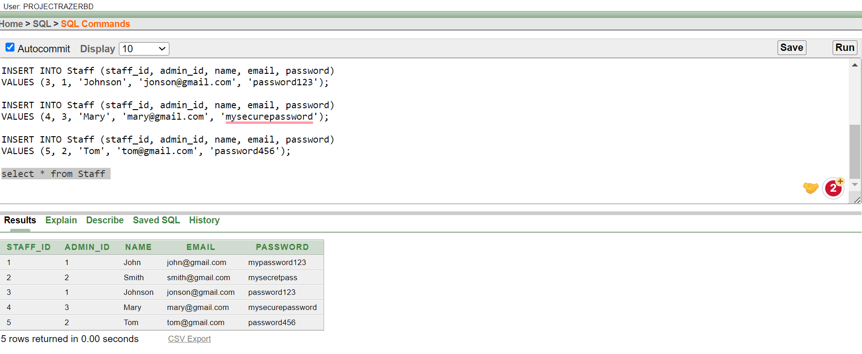

**Warehouse Table:**

**Query Writing:**

**Questions:**

1. Write a query to retrieve the name and email of all users who have placed an order.
2. Write a query to retrieve the total quantity of Razor Keyboard in the warehouse.
3. Write a query to retrieve the highest-priced item in the warehouse.
4. Write a query to retrieve the details of all items in the warehouse that are currently out of stock.
5. Write a query to retrieve the total cost of all orders placed by user id 1.
6. Write a query to retrieve the name and email of all users who have placed an order using Cash on delivery.
7. Write a query to retrieve the name and email of all users who have commented on a product.
8. Write a query to retrieve the details of all orders that have a total cost greater than 200.
9. Write a query to retrieve the list of items with a price higher than the average price of all items in the warehouse.
10. Write a query to retrieve the total number of comments in the comments section.

**Answers:**

1. SELECT u.Name, u.Email FROM user_data u JOIN user_orders o ON u.Id = o.Id;
2. SELECT SUM(quantity) FROM Warehouse WHERE item_name = 'Razor Keyboard';
3. SELECT * FROM Warehouse WHERE price = (SELECT MAX(price) FROM Warehouse);
4. SELECT * FROM Warehouse WHERE quantity = 0;
5. SELECT SUM(Product_total) FROM user_orders WHERE Id = '1';
6. SELECT u.Name, u.Email FROM user_data u JOIN user_orders o ON u.Id = o.Id WHERE o.Pay_method ='COD';
7. SELECT c.Namec, c.Emailc FROM comments_section c JOIN user_data u ON c.Idc = u.Id;
8. SELECT * FROM user_orders WHERE Product_total > 200;
9. SELECT *FROM WarehouseWHERE price > (SELECT AVG(price) FROM Warehouse);
10. SELECT COUNT(*) comment_count FROM comments_section;

**User Interface for Login and Registration:**



